Preliminary Questions from peer review experts
TOPIC-2 (Chapter 6) “Loss of Electrical Power and Loss of Ultimate Heat Sink
Batch 1
- CS, KS: could you please provide a cross section map with indication of the main buildings for the sites?

CS:
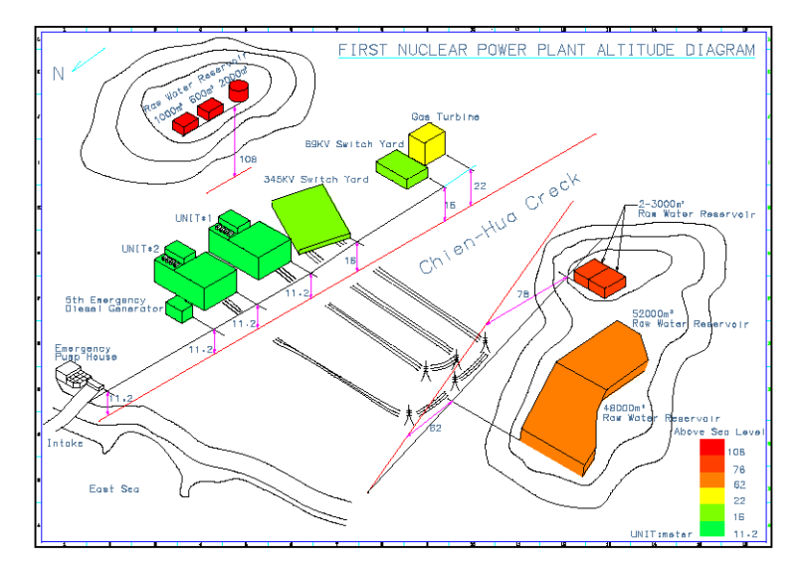

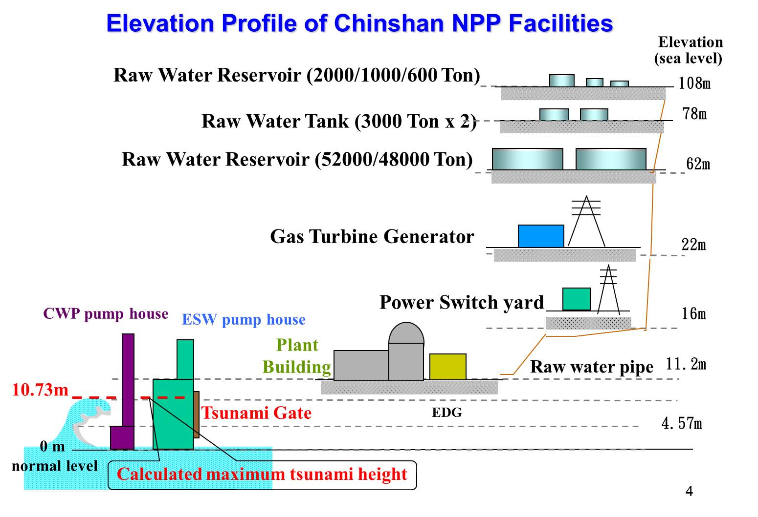

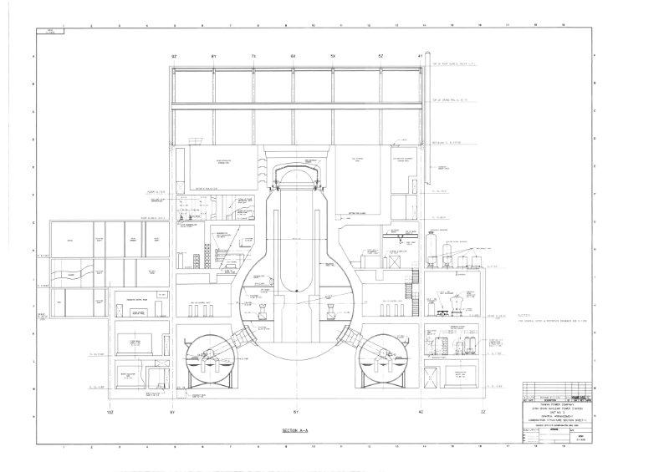

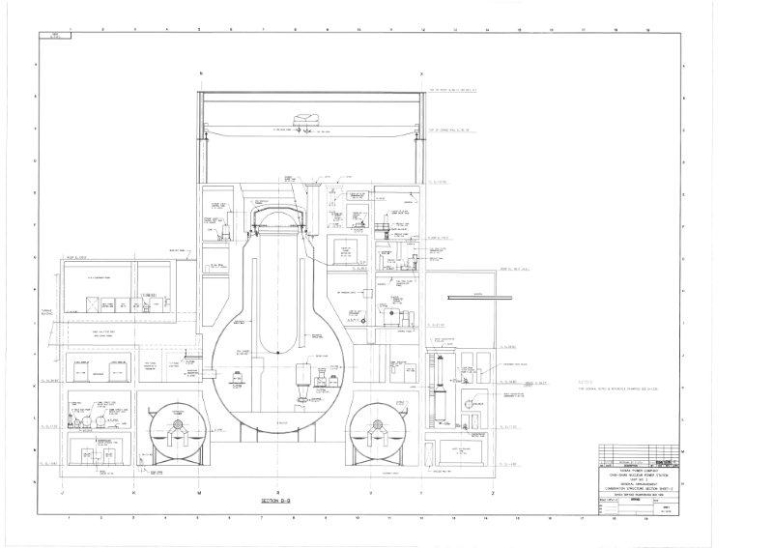

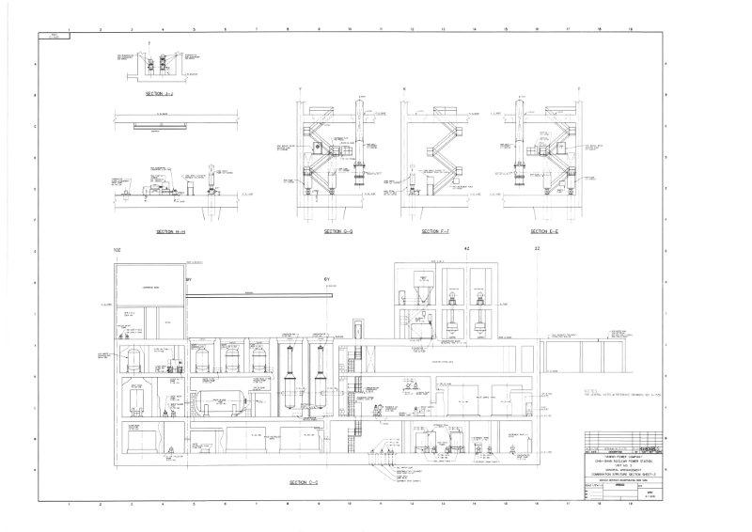

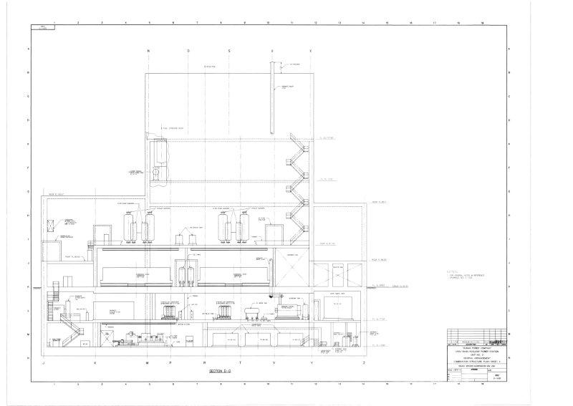

KS:

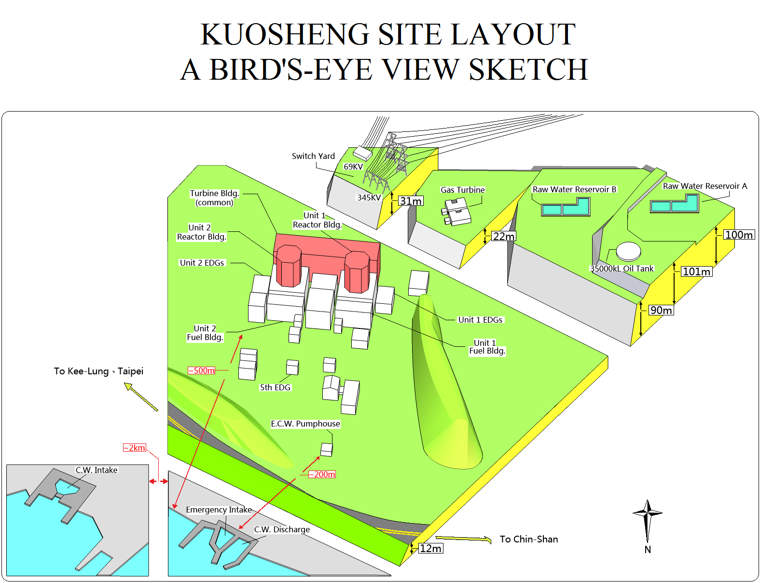

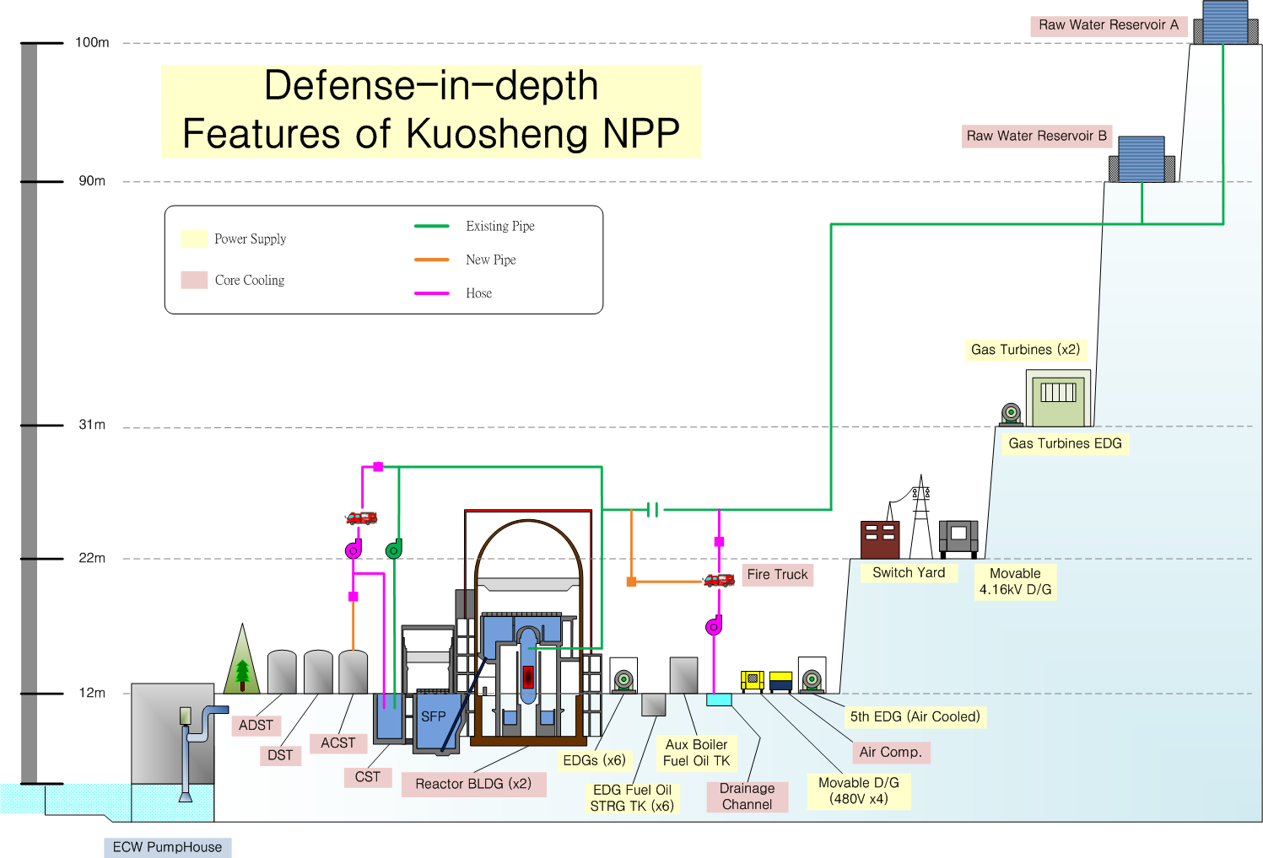

A-14
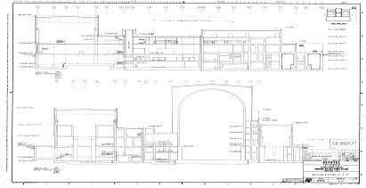

A-15
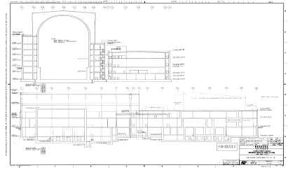

C-2142
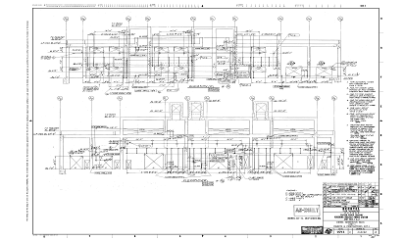

C-2146
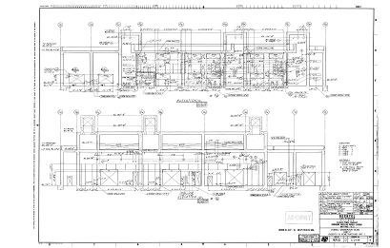

- CS, KS: could you please provide a short description of the ECCS at CS and KS. In particular, the number of redundant trains and the dedicated power supply for each train could be included. Could you please provide a short description of RPV depressurization means for both sites?

CS:
(1)Description of ECCS sub-system:

SYSTEM | Quantity and  Capacity/each | Design flow/each | Pressure  Range | Power
HPCI | 1×100% | 4,250gpm@1120psi | 1120~150psi | DC
SRV | 10×25%(Including ADS×5) | 800,000 lb/hr | 1110~50psi | DC
CS | 2×100% | 3,720gpm@113psid | 265~0psi | EDG A/B
LPCI | 4×33.3% | 6,560gpm@20psid | 217~0psi | EDG A/B

There is one additional turbine-driven injection system RCIC.

(2)RPV depressurization means:
When entering URG condition Ⅰ or condition Ⅱ, open 1 to 3 SRVs (depending on RPV water level ) and fast controlling reactor depressurization to about 15 kg/cm². At this time, if RCIC and HPCI are unavailable, after confirming the injection flow path line up has been completed, open 5 SRVs and relief the reactor pressure to about 3 kg/cm².
(3) In response to loss of power event due to accidents, Chin Shan is designed with category I 1A/1B/2A/2B/5th EDGs (EDG 1A/1B are for unit 1, EDG 2A/2B are for unit 2). The design capacity of each EDG is 100％ such that with one EDG successfully operated, it is sufficient to provide power to the essential bus. Besides, the air-cooled 5th EDG (or swing EDG) is designed for both units, and can provide full power required for a single unit, or after Fukushima it can provide power for both units under load control. There are two Gas Turbine Generators rated at 50,000 kW each on site which can supply power to 69 kV switchyard and then supply power to ESF bus. After Fukushima accident, CS has purchased one 4.16 kV 1,500 kW power vehicle which can provide power for both units under load control.

KS:
(1)Description of ECCS sub-system:

Division | System | Capacity/each | Dedicated Power
Div I | LPCI A | 100 % | EDG A
Div I | LPCS | 100 % | EDG A
Div II | LPCI B | 100 % | EDG B
Div II | LPCI C | 100 % | EDG B
Div III | HPCS | 100 % | Div III EDG
 | RCIC | Not for LOCA | DC (Turbine-driven)

(2)RPV depressurization means
There are two ways for RPV depressurization:
1.Turbine bypass valve:
The six turbine bypass valves located between main steam pipes and throttle valves are provided with high-pressure operating oil to the servo valve actuator by HPU and are controlled by the demand signals of the bypass valves from SB & PR SYS. The purpose is to make main steam enter the main condenser without passing though the turbine, helping maintain the inlet pressure of the turbine, and enable the valves to open automatically and rapidly when the turbine trips with high speed, reducing RPV pressure rising suddenly due to closure of throttle valves. When the six turbine bypass valves fully open, the total flow is 35% that of full power. The six turbine bypass valves are divided into two groups. Each group consists of a steam chest and three bypass valves and enters the main condenser A and B respectively.
2.Safety relief valve:
There are sixteen SRVs on the four main steam pipes. Seven of these SRVs possess the ability to depressurize automatically and all of the SRVs can be opened manually.
(3) In response to loss of power event due to accidents, Kuosheng is designed with seismic category I unit 1 DIV I/II, Unit 2 DIV I/II EDGs and 5th EDG (swing EDG between unit 1 and unit 2). The design capacity of each EDG is 100％ such that with one EDG successfully operated, it is sufficient to provide power to the essential bus. Besides, the air-cooled 5th EDG is designed for both units, and can provide full power required for a single unit, or after Fukushima it can provide power for both units under load control. There are two Gas Turbine Generators rated at 50,000 kW each on site which can supply power to 69 kV switchyard and then supply power to ESF bus. After Fukushima accident, KS has purchased one 4.16 kV 1,500 kW power vehicle which can provide power for both units under load control.

- CS: could you please provide a translation of the figures on pages 5-196, 5-197, 5-198?

CS:

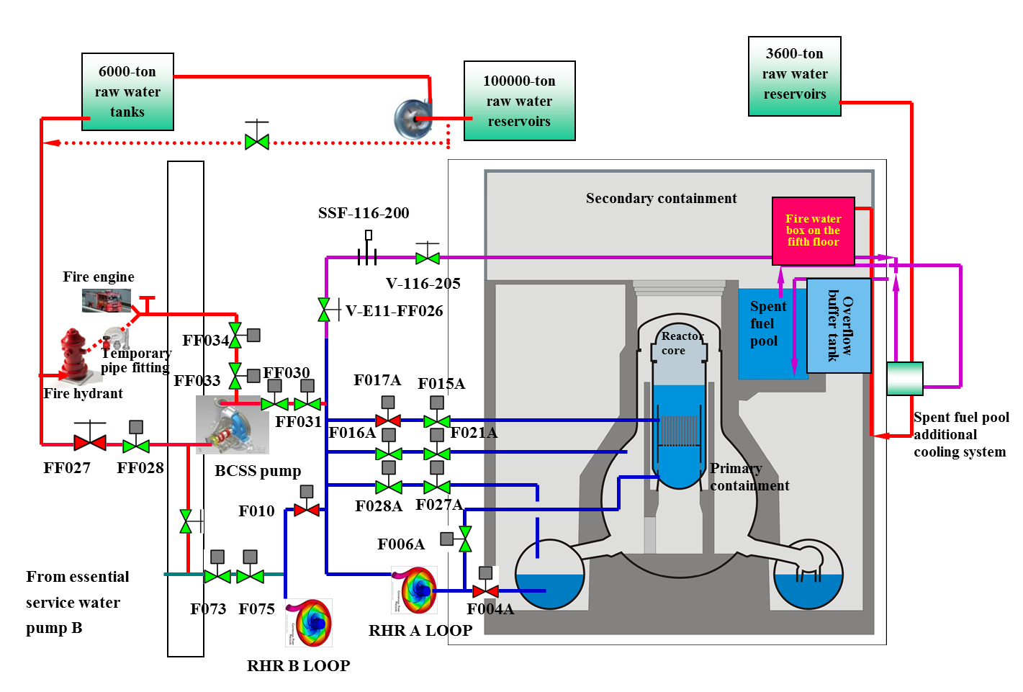

- KS: could you please provide a figure with indication of the elevation of main building and essential equipment (see previous question)?

KS:

- CS, KS: could you please provide a list of the backfits already implemented on the plants by the reference date, indicating also which modifications are planned for the future (including deadlines for realization)?

CS:
(1)DCRs (Design Change Requests) & MMRs(Minor Modification Requests)have been completed

Item | Case No. | Areas of Improvement
1 | C1-1363/  C2-1364 | Improvement of Control Room ceiling
2 | C1-3184/ C2-3185 | To install an additional loop of above-ground Raw Fire Water Pipe. (Part I )
3 | C1-3315/ C2-3316 | To add hydrogen detectors at Reactor building 5F.
4 | C1-3292/ C2-3293 | Based on the recommendation of NEI 06-12，the station has completed DCR-C1-3292/C2-3293 to install new SFP make up water pipes and spray equipment, with the same seismic qualification as the SFP, to increase at least 500gpm water make up capability and 200gpm water spray capability. That will enhance the cooling and make up capability, in an alternative way, for the pool water in case normal SFP make up is unavailable.
5 | C0-3307 | To respond to sudden seizure of tsunami, install motor-operated closing and opening tsunami gates.
6 | C0-3308 | For intake structure: To install metal grid structure at the opening of ESW intake structure to prevent large debris brought by tsunami to enter the trench.
7 | C1-3299/ C2-3300 | The outage service air systems is connected to the plant Instrument / service air system for supplying instrument air in loss of plant Instrument air.
8 | C0-3283 | To install floating valves at the opening for the ESW wash pumps on the second basement floor (B2), which can help release accumulated water on the floor and protect against tsunami.
9 | C1-3295/ C2-3296 | To upgrade the seismic class of EDG Day Tank oil makeup piping to seismic category I
10 | C1-3297/ C2-3298 | Blowout Panel at Reactor building 5F has both remote control and manual control functions. In composite event, Blowout Panel will be opened to prevent hydrogen accumulation within the plant and prevent hydrogen explosion.
11 | C1-3319/ C2-3320 | If continuous actuation of ADS/SRV is considered (DCR-C1/C2-3319/3320 have been completed), air supply can actuate ADS/SRV for 43.2 hours. If not operating continuously, N₂ can be supplied for longer time.
12 | MMR  C1-0413/ C2-0414 | The frame mounted cranes, hoists and cantilever crane in reactor building 5F and turbine building 3F will be fixed.

(2) DCRs & MMRs will be completed
Item | Case No. |  | Areas of Improvement
1 |  | C0-3312 | The design change request DCR-C0-3312 has been approved. Based on this DCR, TSC lighting and ventilation control panel will be modified to have connecting points (including backup TSC) with movable diesel generators. The power transformer of the TSC building lighting system (including backup TSC has been removed from the 1st floor outdoor to a higher elevation) (2014.5.28)
2 |  | C1-3313/ C2-3314 | DCR-C1-3313: Since the procurement of safety-related components takes longer time, the proposed modification of 480V power source will be completed in two stages. The wiring from the movable diesel generators to the manual switchgear box (non-safety related component) will be completed in the 1st stage. The wiring from the manual switchgear box to MCC (safety related component) will be completed in the 2nd stage. This DCR will be completed at Unit 1 EOC-27. (2014.12.24)  DCR-C2-3314: Same as Unit 1 except this DCR will be completed at Unit 2 EOC-26. (2014.5.28)
3 |  | C1-3184/ C2-3185 | To install an additional loop of above-ground Raw Fire Water Pipe (Part II, 2015.2.28 )
4 |  | C1-3301/ C2-3302 | The main control room air conditioning system will be added with two each 100% air-cooled water chiller, under the composite events to supply main control room with required air conditioning capacity (Unit1:2014.12.24; Unit 2:2015.12.16)
5 |  | C1-3303/ C2-3304 | BCSS capacity will be increased from original 250gpm to improved 800gpm.  (Unit1:2014.12.24; Unit 2:2014.5.28)
6 |  | C0-3294 | To install an additional gravity pipe from the 100,000 Tons lower raw water reservoir (Unit1:2014.12.24; Unit 2:2014.5.28)
7 |  | C1-3305/ C2-3306 | To enhance HCVS & add FCVS system (Unit1:2016.05.31; Unit 2:2017.5.31)
8 |  | C1-3310/ C2-3311 | To upgrade the seismic class of SFPACS Cooling Tower CT-15A/B associated piping to seismic category I. This DCR can provide the alternative to reactor, drywell, suppression pool, and spent fuel pool heat removal system in case that compound disaster accident happens. (2013.8.20 Vendor will complete the design)
9 |  | C2-3309 | To establish # 2 Conference Room (i.e. seismic TSC) with ventilation filtration equipment and power improvements(2014.5.28)
10 |  | MMR  C1-0404/ C2-0405 | Fire protection doors R1, R8, R-23, T21, T-22, T-2, T-6 and T-9 will be improved for water-tightness (2014.4.30)
11 |  | MMR  C0-0407 | To Install water tight doors at the entrances of 5th EDG building (2013.12.31)
12 |  | E-3028/ E3029 | To install water level indicator and temperature indicator for SFP (Unit1:2014.12.24; Unit 2:2014.5.28)
13 |  |  | CS plans to construct a 170 m long anti-tsunami seawall which is 17 m above the sea level and to build an another anti-tsunami wall in ESW pump house in order to protect the equipment.inside (2016.12.31)

KS:
1.Replace all underground raw water pipes with new pipes housed in trenches on ground level | Completed
2.Add mobile 480V/3Ø 200kW power connections for 1/2B3A and 1/2B4A load center. | Completed
3.Add power connection from TSC’s 480V 200kW DG to 1/2B3A load center | Completed
4.Add routes from 4.16kV 1100kW black-start diesel generator (Gas Turbine) to plant 4.16kW bus. | Completed
5.Reroute power source from 1/2C1D48 TO 1/2C3F so that reactor building normal ventilation fan 1/2VR4 can be powered from external mobile DG. | Completed
6.Enhance battery system A’s capacity to 24 hours. | Dec. 2014
7.Upgrade spent fuel pool level instrument, according to USNRC EA-12-051 | June 2016
8.Add two series DS on line side of 1/2A213 for connection to 1/2A7 bus. | Completed
9.Add compressed air connection and pipes from outside of auxiliary building to SRV’s(for mobile air compressor use) | Completed
10.Add fire hydrant connection to DST and ADST drain line | Completed
11.Add shutoff valves and quick connections to ECW lines for mobile pumps to pump water to RHR HX. | Completed
12.Add valves and pipes from CST to external of SPF building. | Completed
13.Add spent fuel pool water spray via quick connections from outside SPF Building | Completed
14.Add makeup water line to spent fuel pool via quick connections from outside SPF Building | Completed
15.Add shutoff valves and quick connections from raw water supply lines for NCCW HX as alternate cooling. | Completed
16.Procure mobile 4.16kV/1500kW DG and add routes from switch yard to plant 4.16kV bus. | Completed
17.Add water lines from external TB building to RHR | Completed
18.Build anti-tsunami seawall which is 17 m above the sea level | Dec. 2016
19.Install FCVS system | Planning Stage
20.Construction of a new seismic isolation ERC | June 2016

- CS: up to which acceleration (pga) is the equipment (pump, piping) used to refill the daily tank seismic-proof?
CS:
All the equipment required to refill daily tank are seismic category Ⅰdesign..

- KS: is there a daily tank? In case please provide information about the seismic design of the refilling system.
KS:
Each EDG is equipped with a daily tank. EDG’s fuel transfer systems are seismic category Ⅰdesign

- KS: could you please specify the available DC time for essential loads before recharging the batteries becomes necessary?
KS: Time for the safety related DC batteries for essential loads before recharging are as follows:
DC system A: 12.8 hours (will be upgraded to meet 24 hours requirement before October, 2014)
DC system B: 24.5 hours
DC system C: 26.8 hours
DC system D: 26.8 hours
- KS: you indicate that RCIC can be manually restarted if its DC power supply has been lost and that the associated operation has been demonstrated. Could you please indicate which time frame is necessary for conducting the associated operation and how radioprotection issues have been tackled?
KS:
If DC power system is not available but the RPV pressure can still make RCIC operable, RCIC could be started up manually, injecting water into the reactor.
RPV is scrammed before starting up RCIC manually. Equipment that needs to be operated manually is in the auxiliary building and the main steam tunnel, both are situated outside the containment and are all accessible. Radiation protection is implemented according to current regulations, such as wearing masks if there is aerosol in air.
On-site manual start-up of RCIC is one of the B.5.b strategies listed in NEI 06-12. The operational methods are listed in the procedure 1451 URG guidelines and verified to be operable by demonstration during outage. The operation can be accomplished in 30 minutes.
When the system operates as power is lost, mechanical flow meters are added onto the local instrument raceway monitoring the practical operational flow situation of the injection into the RPV. Besides, rotation speed monitoring will use a synchronizer to measure the local speed to prevent over-speed trip during operation.

- CS: you mention for example that it takes about 10 minutes for fire engines to drive from the Shiman district to the NPP. Could you please comment on what provisions are available in case roads and the surroundings of the NPP is disrupted (e.g. for a Fukushima-like scenario)?
CS：
1. Considering the case the access roads and the surroundings of the NPP are disrupted due to road blockade, CS has two fire brigades outside the plant in different directions as the rescue back-up to cope with this possible traffic disruption: one is Shimen fire brigade, and the other one is Kuosheng nuclear power plant fire brigade.
2. The arrival of small light rescue equipment from outside should be within 24 hours, and the arrival of large heavy rescue equipment from outside should be within 72 hours. However, the plant has the autonomy rescue capability more than 72 hours.

- CS: the design basis for calculating flood protection against tsunamis is 10.7 m. Could you please provide an estimation of the return period of such an event leading to the 10.7 m flooding elevation?
CS:
1. The return period of such an event leading to the 10.7 m flooding elevation was not mentioned in CS FSAR.
2 .FASR 2.6.10
The design of jetties for seashore protection is based on the maximum possible wave height of 7.4 m (which is based on the historical record investigation) and the maximum tsunami run-up of 6.5 m to 9.0 m above the mean high water level with the seaward slope between 1/10 to 1/5.
The design maximum elevation of wave height is 10.73 m (9 m + storm tide of 1.73 m = 10.73 m).
3. According to NTTF 2.1 requirement, tsunami hazard re-assessment with 10,000 years return period is progressing.

- CS: you mention that the NPP has tsunami protection up to 11.34 m height. Could you please provide a quantification of the safety margin in terms of return period, e.g. (return period 11.34 m)/(return period 10.7 m) ?
CS:
1. The return period of such an event leading to the 10.7 m flooding elevation was not mentioned in FSAR, there is no return period for 11.34m, neither. The maximum design elevation of wave height 10.7 meter is evaluated by historical record under the following two assumptions:
a) All tsunamis which arose in the central and western part of the Pacific Ocean have no destructive effect on the northern coast of Taiwan. This can be proven by past records and refraction diagrams.
b) Two tsunamis recorded at Keelung in 1867 and 1918 could be regarded as the result of north eastern submerged volcanic eruption.
The quantification of the safety margin of return period was not mentioned in FSAR.
2. According to NTTF 2.1 requirement, tsunami hazard re-assessment with 10,000 years return period is progressing.

- KS: you mention that the NPP has tsunami protection up to 12 m height. Could you please provide a quantification of the safety margin in terms of return period, e.g. (return period 12 m)/(return period 10.28 m) ?
KS:
1. The return period of such an event leading to the 10.28 m flooding elevation was not mentioned in FSAR, there has no return period for 12 m, neither. The maximum design elevation of wave height 10.28 meter is evaluated by historical record under the following two assumptions:
a) All tsunamis arising in the central and western part of the Pacific Ocean have no destructive effect on the northern coast of Taiwan.
b) Two tsunamis recorded at Keelung in 1867 and in 1918 are regarded as responses to north-eastern submarine volcanic eruption.
The quantification of the safety margin of return period was not mentioned in FSAR.
2. According to NTTF 2.1 requirement, tsunami hazard re-assessment with 10,000 years return period is progressing.

- CS: could you please provide details on the existing retention functionalities for the suppression pool venting and for the drywell venting in terms of decontamination factors for aerosols, iodine and noble gases?
CS:
1. When aerosols,iodine and noble gases contact with the water surface of the suppression pool, iodine or aerosols are likely to be kept in water and not released, but noble gases will be released into the containment.
2. The venting path of the drywell and suppression pool is via SBGT.
D.F.=1/(1- Efficiency)

 | HEPA Efficiency % | HECA Efficiency %
Unit 1 SBGT-A (EOC26) | 99.980 | 99.985
Unit 1 SBGT-B (EOC26) | 99.985 | 99.990
Unit 2 SBGT-A (EOC25) | 99.965 | 99.970
Unit 2 SBGT-B (EOC25) | 99.985 | 99.975

The venting path of the drywell and suppression pool is venting after being filtered via SGTS. This can deal with aerosol, iodine effectively.

- KS: could you please provide details on the existing retention functionalities for the suppression pool venting and for the drywell venting in terms of decontamination factors for aerosols, iodine and noble gases?
KS:
1. The venting path of the drywell is through the horizontal vents of the suppression pool and into the containment. When air in the drywell makes contact with the water surface of the suppression pool, iodine or aerosol are likely to be kept in water and not released, but noble gas will be released into the containment.
2. The venting path of the containment is venting after being filtered via SGTS. The dose reduction factor of the SGTS filter assembly for the thyroid dose following a postulated LOCA is l00. No credit is taken for any holdup of noble gases on the filters. The Efficiency (%) of CHARCOAL FILTER is 99.0 (elemental iodine) and 99.0 (organic iodine). This can deal with aerosol, iodine effectively.

- KS: could you please provide an estimation of the time needed for support from the Military Emergency Center to be deployed on site?
KS:
The timing of support from Military Emergency Center outside the plant is coordinated by the Nuclear Emergency Response Center. The power plant has no control of it. Based on the fact that Taiwan is a small island, It is supposed that the military support could be deployed to KS site after 12 hours upon receiving request.

- CS, KS: could you please comment whether loss of ultimate heat sink together with SBO could lead more rapidly to core damage than any of the two conditions alone?
CS,KS:
Under current designs of Chinshan and Kuosheng plants, the difference between SBO alone and SBO plus LUHS is that RCIC will trip earlier in the latter case and will eventually result in a more rapid core damage accordingly.
Considering all the Taipower’s NPPs have additional air-cooled 5th diesel generator and Gas Turbine Generators, either SBO or LUHS event will be under control as follows;
Station Blackout:
During a SBO, either 5th diesel generator or Gas Turbine Generators can supply the power to ESF BUS of each unit, so ECCS systems still work. The accident will be under control.
Loss of Ultimate Heat Sink:
During this condition, the power to ESF Bus can be supplied by either 5th diesel generator or Gas Turbine Generators, but the reactor residual heat cannot be removed from reactor to the environment via RHR system. The path to remove the reactor residual heat is feeding the water into the reactor and blowing down via the SRVs into the suppression pool. However, the heat of the suppression pool cannot be removed, so the CTMT ventilation expels the heat from the containment. This strategy is adequate to mitigate the accident.
Loss of Ultimate Heat Sink and Station Breakout:
This kind of accident is the same as Loss of Ultimate Heat Sink.
After the Fukushima accident, the CS and KS NPPs implemented many improvements to enhance the nuclear safety. They are the movable 1500kW power vehicle which supply 4.16 kV ESF bus, 480V MCCs, and secondary heat sink. In this case, the secondary heat sink is water intake from the sea water canal instead of ECW system.

- CS: could you indicate the time after shutdown you assume as basis for the figure of 6.25°C/h (SFP water temperature increase)?
CS:
If Chinshan has to do full core discharge, all fuel assemblies will be removed from core to spent fuel pool on the 7th day after shutdown. The time assumed as the basis for the rate of 6.25 °C/h is the 7th day after shutdown.

- KS: could you please specify whether the 10 days after shutdown, as assumed in scenario 3, correspond to the most penalizing situation during refuelling (i.e., max total decay heat to be removed from the SFP)?
KS:
At Kuosheng plant, the most penalizing situation during refuelling will happen when all the discharged fuel assemblies have been transferred from the upper pool to spent fuel pool. It usually happens on the 10th ~ 20th day after shutdown.

- Point (2): you mention that the considerations for the extended SBO scenario up to 72 hours can be based on realistic analyses with reasonable operator action. Could you please give further details about what is meant by 'reasonable operator actions'?
All four nuclear power plants of Taipower have implemented the betterment according to the SBO requirement of 10CFR 50.63.
After Fukushima accident, the realistic analyses have been performed to extend the SBO coping time from 8 hours to 72 hours after considering operator actions including containment venting, opening of RCIC room door, lineup of alternative water sources, and manual safety relief valve operation,etc.

Preliminary Questions from peer review experts
TOPIC-2 (Chapter 5)
Batch 2
- According to ENSREG "stress test" specification the time to severe damage of the fuel for each situation linked to LOOP, SBO, LUHS should be provided (page 10, last paragraph and page 11, 4 paragraph of the specification).
1. The times for the situations are not clearly provided; 2. On page 113 of the National report is mentioned that the raw water can be supplied for 86.84 hours, but it is not clarified that the mentioned measures prevent fuel damage; Corresponding conclusions and clarifications should be provided

LM:
(1). Under current designs of Lungmen plants, the difference between SBO alone and SBO plus LUHS is that RCIC will trip earlier in the latter case and will eventually result in a more rapid core damage accordingly. Considering all the Taipower’s NPPs have an additional air-cooled 5th diesel generator (SDG) and two Gas Turbine Generators (G/T), either SBO or LUHS event will be under control as follows:
Under LOOP situation, there are #1/2 EDG A/B/C, SDG, 2G/Ts, mobile DG still available, this scenario is under control, so estimate of time to severe damage of the fuel is eliminated. Under SBO situation ,there are #1(or #2) EDG A/B/C, SDG,2G/Ts, mobile DG available, this scenario is under control, so estimate of time to severe damage of the fuel is eliminated. Under LUHS situation, it can remove the reactor residual heat by feed-and-bleed, through the DST, CST, Fire Water Tank, Raw Water Reservoir, River, Sea Water substituted, so estimate of time to severe damage of the fuel is eliminated.
(2). After reactor depressurization, the low pressure injection flow by gravity from raw water reservoir located at high elevation can inject water into reactor as described in pages 168 & 169, chapter 5.1.4.3 of Lungmen NPP’s stress test report. For the foreseen actions to prevent fuel degradation, there are paths showing raw water reservoir→ OP16→BV5250→ E11-BV45C/46C→E11-MBV5C to RPV (and E11-MBV32C/33C to SFP).

- The analysis of lubrication oil stock and other items, that are necessary for EDG operation, should be done and corresponding conclusions provided.

LM:
Each EDG is equipped with one lube oil tank with 4.316kL capacity. It can provide 1 EDG to run continuously for more than 7days.
Each EDG is equipped with one fuel day tank with 12 kilolitres capacity and one fuel storage tank with 450 kiloliter capacity. They can provide 1 EDG to run continuously for 5 hours and 7days, respectively. Fuel storage tank has gas cap to make up fuel from tank truck. No other items should be concerned about for EDG operation.

- 2 paragraph, item (2). It is mentioned, that RCIC can be run manually. 1. For such operation some I&C is needed. That provisions for I&C are? Is it planned to use the mobile equipment? 2. Is it planned to test manual start-up and operation of the RCIC system during commissioning of NPP and (or) operation?

LM:
(1).8 to 21 hours after station blackout incident, stop valve(uv104) will fail closed due to de-energized solenoid . Manually open stop valve will keep RCIC continuous running ( RCIC is equipped with mechanical governor, no I&C needed ), operators still monitor suction/ discharge pressure, discharge flow, and speed from main control room and locally.
(2).Procedure POTP 006: RCIC Pre-Op Test has been conducted to manually open uv104 to verify RCIC operation.

- Item 6 (3). It is mentioned that after 15.6 hours after reactor depressurization and water injection, suppression pool water level will increase to the elevation of vent port disabling venting possibility. Are measures for preventing or mitigation of such situation foreseen?

LM:
Referring to SAG (procedure1450) Section RC/F6:If primary containment water level & wetwell pressure can not be kept below the primary containment pressure limit, i.e., with high suppression pool level 17.15m or wetwell 652kPaG (COPS disabled), terminate direct injection into the containment from sources external to the primary containment (CST,DST,ACIWA). As a consequence, wetwell can not be vented and drywell vent will be implemented instead.

- Paragraph 5. It is mentioned measures for prevention of hydrogen risk in the secondary containment. Is corresponding equipment for control of hydrogen concentration and (or) burn it designed or planned to be installed in the secondary containment?

LM:
Since hydrogen is not expected to exist in the secondary containment, thus currently no hydrogen monitor installed, and secondary containment exhaust fans or SGT are used to vent air or H₂.

Preliminary Questions from peer review experts
TOPIC-2 (Chapter 5)
Batch 3
- Does the PSA of NPPs (not the stress test) include outside man initiated (not malevolent) events? Does it include partial load - low power (not full power and not refuelling) modes of operation?

The update of external events screening is on-going per ASME PRA Standard. The screening process will include an examination of potential man-made events such as aircraft impact, nearby industry facilities accidents, transportation event, etc.

Currently not every PSA model covers the low power mode of operation.

CS, KS:
At present CS and KS NPP PRA models include in-site transient, LOCA, floods and fire accident; off-site include earthquake, typhoon but not sabotage.
The mitigation system of low power PRA is the same as full power, and low power is relatively conservative. So full power PRA is adopted rather than lower power PRA.

MS:
MSNPP PSA model has neither the outside man initiated (not malevolent) events, nor the low-load power state.

LM:
a) No, the PSA mode of LMNPP does not include outside man initiated (not malevolent) events, because the frequency of outside man initiated event is low enough to be screened out.
b) Yes, the PSA mode of LMNPP included partial load - low power modes of operation.

- Is it required by regulations, or is it otherwise in practice to implement regularly a periodic safety review (PSR) of the NPPs by the operators?

YES. According to Article 9 of the Nuclear Reactor Facilities Regulation Act, after nuclear reactor facilities have been formally operated, one integrated safety assessment at least shall be implemented every ten years and then be submitted to the competent authorities for review and approval.(additional information is provided in Response to Question 2 of Topic 3)

- Please give clarification to essence of AEC order 10107: what means "the capability of the swing EDG to back up the other unit is restricted", and also, for a unit or for a plant "Requiring more than 2 EDGs", as 2 is less than "more than 2".

- The swing EDG is originally designed to power only one ESF bus for any unit at one time. In the light of the significance of on-site electrical power for an unit at refuelling outage(one EDG is normally inoperable during this period), AEC requested TPC to keep two EDG operable for the unit at refuelling outage. This means that the swing EDG has to be aligned to the unit at refuelling outage, so the capability of the swing EDG to back up the other units in operation(e.g., when performing the on-line maintenance) is restricted.
- The description “more than two” should be revised to “at least two”.
- Please give clarification to essence of AEC order 10110: How to understand "install a seismic qualified extra gas-cooled EDG". Anyhow to add one such EDG, or only in the case, when the existing swing EDG is not qualified properly?

The existing swing EDG is seismically qualified. However, they are all located in the ground level which is vulnerable to flooding. Adding an extra one at higher elevation is in the consideration of Defense-In-Depth. Alternatively, if TPC upgrade the water-proof capabilities of the existing swing EDG to cope with possible external floods, it may be accepted by AEC. In this case, no extra gas-cooled EDG is required to be installed.

- Is foreseen in NPPs or in some of those to drop the load to in-house consumption level in case of LOOP, and stay at this level, this way giving possibility to feed the other unit on the site, if it would be required?

CS, KS:
In case of LOOP, the reactor is not allowed to be operated for in-house load. For ultimate mitigation, the emergency diesel generators or gas turbine generators are able to feed to the other unit on the site through special line up, which is described in procedure 1451.

MS, LM:
In case of LOOP, the reactor power load will be automatically dropped to in-house load due to the unit design. However, according the current EOP and AOP, the reactor has to be shutdown, never allowed to operate for in-house load. The emergency diesel generators or gas turbine generators will be responsible for in-house load.

- Div. III EDG provides power to HPCS only. Does it mean, that HPCS has only one division, and that in design basis situations only one EDG is devoted to HPCS?

KS:
Yes, HPCS has only one division, and that in design basis situations only Div. III EDG is devoted to HPCS if the plant lost the offsite power. But there has a turbine driven high pressure injection system RCIC, with rated flow about 1/10 of HPCS.
- Is HIS for design basis events, or only for BDB events? In first case why the system has only one standby back-up diesel. Is this "specific" diesel one of the Div I, or II or III diesels, or a further specific diesel?

KS:
Hydrogen Ignition System (HIS) is for design basis events. There have two divisions, division I and division II. The normal power supply for the HIS is provided by ESF Buses, 1(2) C3D19 and 1(2) C4D17, with standby diesel generators (Div.I EDG and Div.II EDG) as backup. Based on the above description, if the plant lost the offsite power, the Div.I EDG supplies the power to A3 bus which 1(2) C3D19 is the downstream of the A3 bus and the Div.II EDG supplies the power to A4 bus which 1(2) C4D17 is the downstream of the A4 bus. Besides, one additional dedicated diesel generator can supply power to HIS when SBO happened.

- There is stated on pages 110-111, 112, that no specific power cables exist between CS NPP and KS NPP, as well with the nearby fossil power plants. Contrary to that on pages 121 and 138 existence of such cables is stated. What is the real situation, and in what circumstances these dedicated cables are used for providing "extra" outside power? To what extent these are more protected or reliable than the general HV network?

CS, KS:
No specific power cables exist between CS NPP and KS NPP, as well with the nearby fossil power plants. They are connected via general High Voltage transmission network.

- Text related to MS NPP item 4 Note (1) needs clarification: what are the mentioned items 1÷3?

MS:
item 1~3 means equipment mentioned from item 1 to item 3

- Please give additional information on function of LM NPP's Auxiliary Fuel Building, and on what quantity of spent fuel is contained in it, and what is the cooling time before fuel is transported here for storage?

LM:
1.The function of AFB is to enclose Aux Fuel Pool (AFP), AFPC (maintaining pool water level, quality, and removing radioactive material from the pool),SDG (replacing #1 or #2 EDG),and 5 AFB HVAC (providing a suitable room temperature).
2.The heat load conditions existing in the AFP are defined based on the discharged fuel being stored for 13.5 years (one fuel cycle earlier than 15 years) in the RB Fuel Pool before storage in the AFP.
3.The storage capacity for the AFP is that required to store spent fuel resulting from 25 years of reactor operation for 2 units (total 872 Fuel Assemblies/ unit ×1/3÷1.5 years × 25 years × 2 units).

- In items 2, 3, 4 and 5 of LM NPP probably reference should be made to Section 5.1.3.4 instead of Section 5.1.2.4

LM:
The statement is correct. It only describes that references of items 2, 3, 4, 5 in Section 5.1.3.4(Loss of offsite power, EDG A/ B/C and SDG) are same as references of items 2,3,4,5 in Section 5.1.2.4( Loss of offsite power, EDG A/ B/C, but SDG still available).

- No. 2 and 3. deep wells are considered as a source of the SG make-up water, or other needs to provide additional heat sink. Are they public wells? Who is the operator (may be the MS NPOP)? What category is the power distribution system required to operate it?

MS:
No. 2 and 3 deep wells are owned by the MSNPP, and are operated by station staff. The normal electric power supply for No. 2 and 3 deep wells is non safety-related. Maanshan has installed connection panels for mobile diesel generator.
- There are very important additional requirements of the AEC e. g related to SFP instrumentation, as it seems, that in NPPs less attention was devoted to these items (e.g. 14 and 15.)

According to NRC JLD-ISG-2012-03 and NEI 12-02 Rev.1, AEC requires TPC to install two reliable water level instruments for each spent fuel pool. Besides, TPC will also follow ROCAEC’s request to install the temperature instrument for each spent fuel pool. These SFP instrumentations help and enhance plant staff to monitor the key spent fuel pool parameters. The installation due dates for each plant are as follows:

NPP/Unit | Installation Due date
CS1 | 12/24/2014
CS2 | 5/28/2014
KS1 | 5/31/2015
KS2 | 4/17/2016
MS1 | 4/27/2015
MS2 | 11/5/2015
LM1 | Before fuel loading
LM2 | Before fuel loading
Above due dates are based on the current Rev 54 of TPC nuclear units long-term energy utilization plan

CS, KS, MS, LM:
All NPPs will install two water level instruments for each spent fuel pool in accordance with NRC JLD-ISG-2012-03 and NEI 12-02 Rev.1. Besides, TPC will also follow ROCAEC’s request to install the temperature instrument for each spent fuel pool.

